The Case Seven Minutes on the Seine
Written by: Yuval Quina
Machine 1:
I started this challenge by entering the link that appeared on the description:
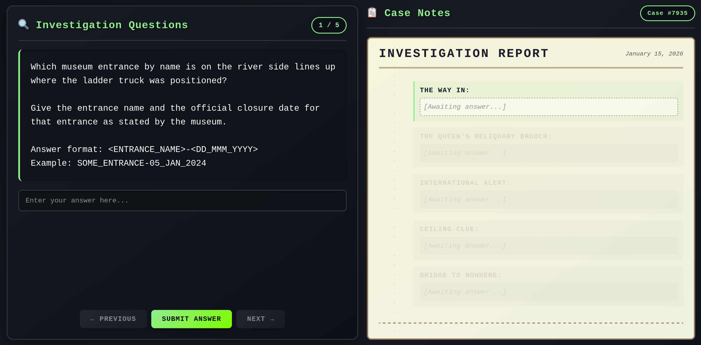
I examined the page a bit and understood that I needed to answer the questions to fill the investigation report. Therefore, I entered some news websites about the robbery case that took place at the “Louvre” museum.

Question1:
The first question was about the entrance name where the ladder truck (that the thieves used to access the gallery) was next to and when the robbery took place.
I found on Wikipedia page of the robbery the exact location where the truck was located:
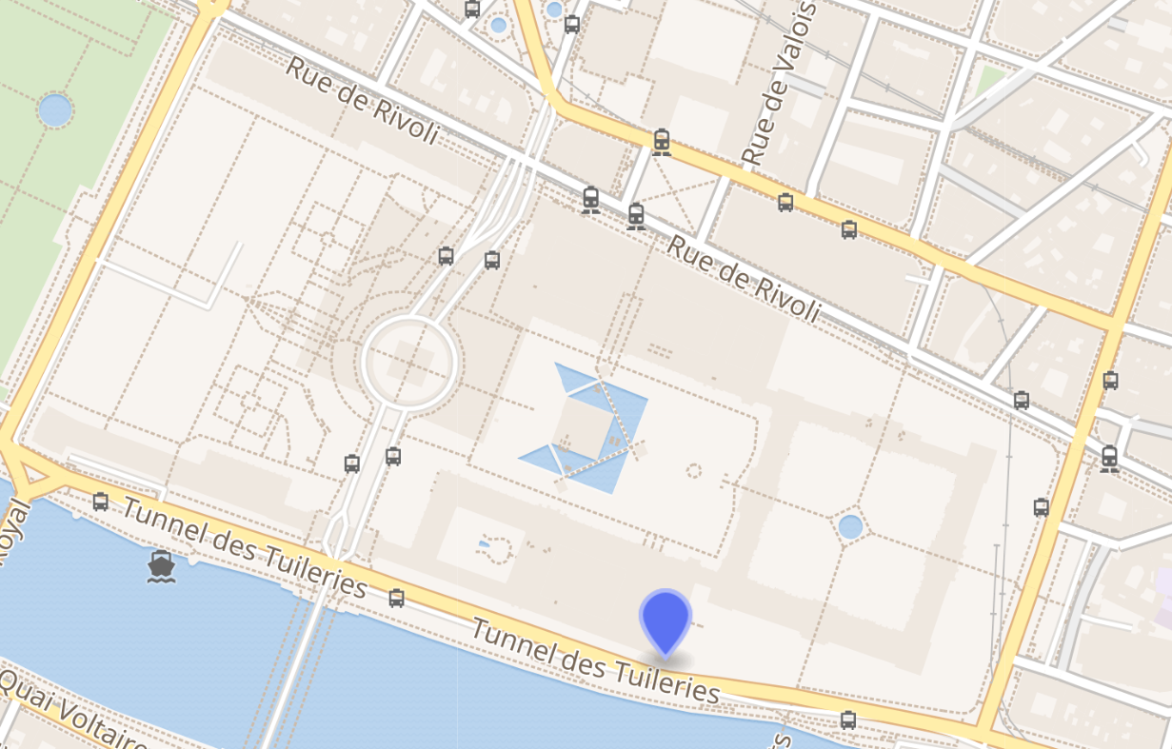
Then, I found this map of the museum itself:
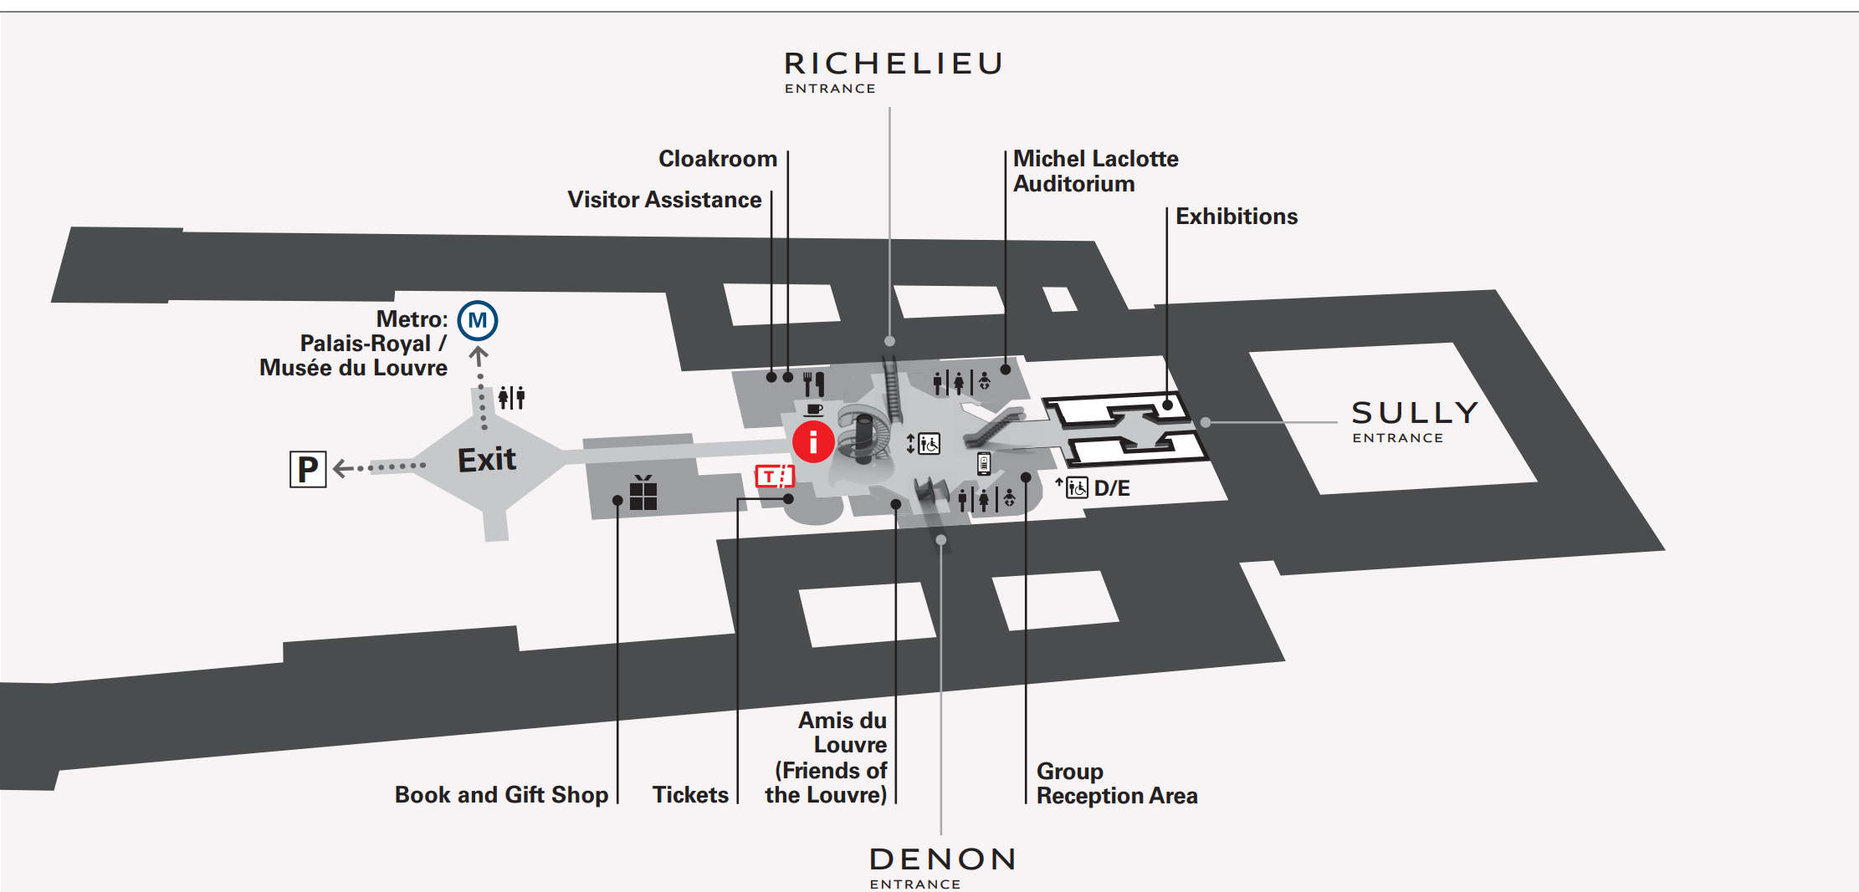
And by crossing the data, I found that the entrance is called “Denon”.
In addition, I found on the same Wikipedia page, that it was closed on 22th October 2025.
Answer:
Porte_des_Lions-22_OCT_2025

Question 2:
Details about the item named “Empress Eugénie's Reliquary Brooch” which was stolen during the heist.
I found on the louver official site’s database the information about it:
https://collections.louvre.fr/en/ark:/53355/cl010114080

Answer:
12238-JOAILLIER-PURCHASED-2008-NON_EXPOSE

Question3:
I found this image on Interpol’s official website:

Answer:
2025/359.1, 2025/359.5

Question 4:
I found this line in the Wikipedia page Galerie d'Apollon: “painter Eugène Delacroix contributing Apollo Slays the Python for the center of the ceiling”
This lead me to search for it in the Louver database and I found it there with full details: https://collections.louvre.fr/en/ark:/53355/cl010065703

Answer:
Apollo_Slays_the_Python-INV_3818-8mx7.5m

Question 5:
I just opened google maps and found it.

Answer:
Carrousel_Bridge

Unfortunately, I got too many errors despite my answer were right:
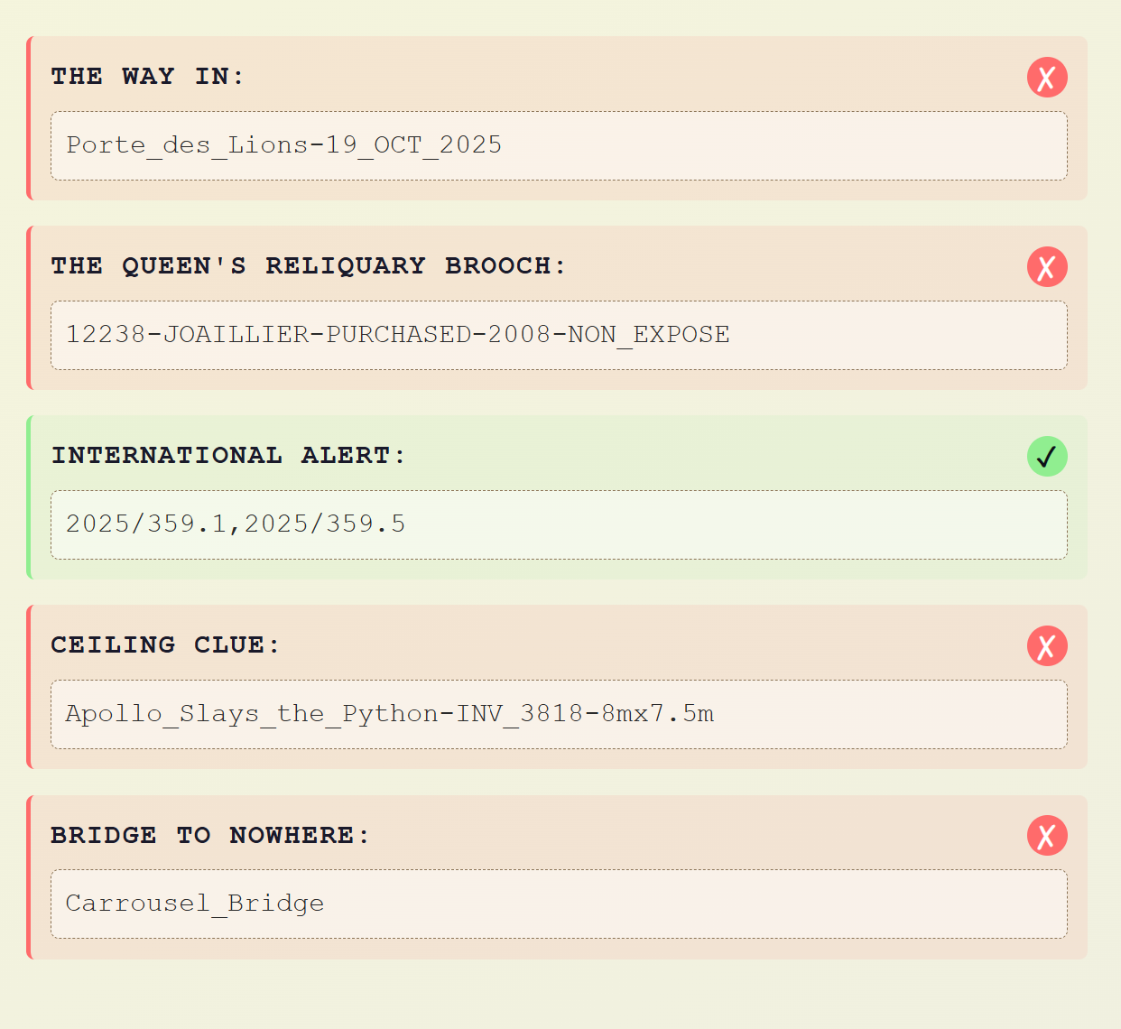
Therefore, I tried to check the checking results request using the Network browser tools:
{
"all_correct": false,
"results": {
"Bridge to Nowhere": {
"correct": false,
"expected": "PONT_ROYAL",
"provided": "Carrousel_Bridge"
},
"Ceiling Clue": {
"correct": false,
"expected": "APOLLON_VAINQUEUR-INV_3818-8mx7.5m",
"provided": "Apollo_Slays_the_Python-INV_3818-8mx7.5m"
},
"International Alert": {
"correct": true,
"expected": "2025/359.1,2025/359.5",
"provided": "2025/359.1,2025/359.5"
},
"The Queen's Reliquary Brooch": {
"correct": false,
"expected": "MV1024-BAPST-AFFECTE-1887-NON_EXPOSE",
"provided": "12238-JOAILLIER-PURCHASED-2008-NON_EXPOSE"
},
"The Way In": {
"correct": false,
"expected": "PORTE_DES_LIONS-22_OCT_2024",
"provided": "Porte_des_Lions-22_OCT_2025"
}
},
"success": true,
"success_message": null
}

I saw here the expected results of the website, so I used them, found the flag and successfully ended the first machine of this challenge:
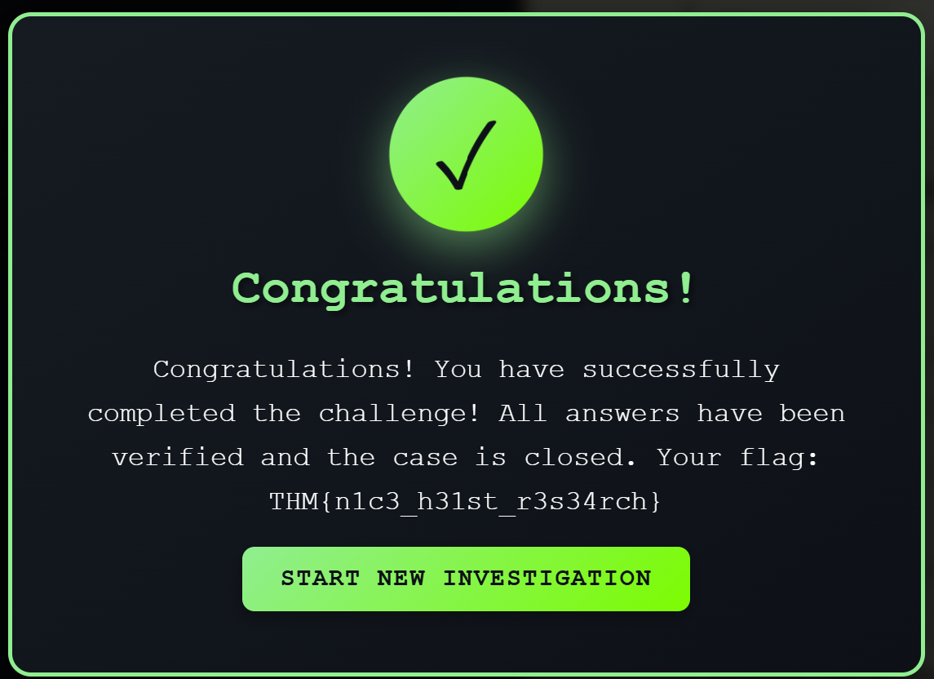

Machine 2:
I started the second machine by entering the link that was provided in the description:
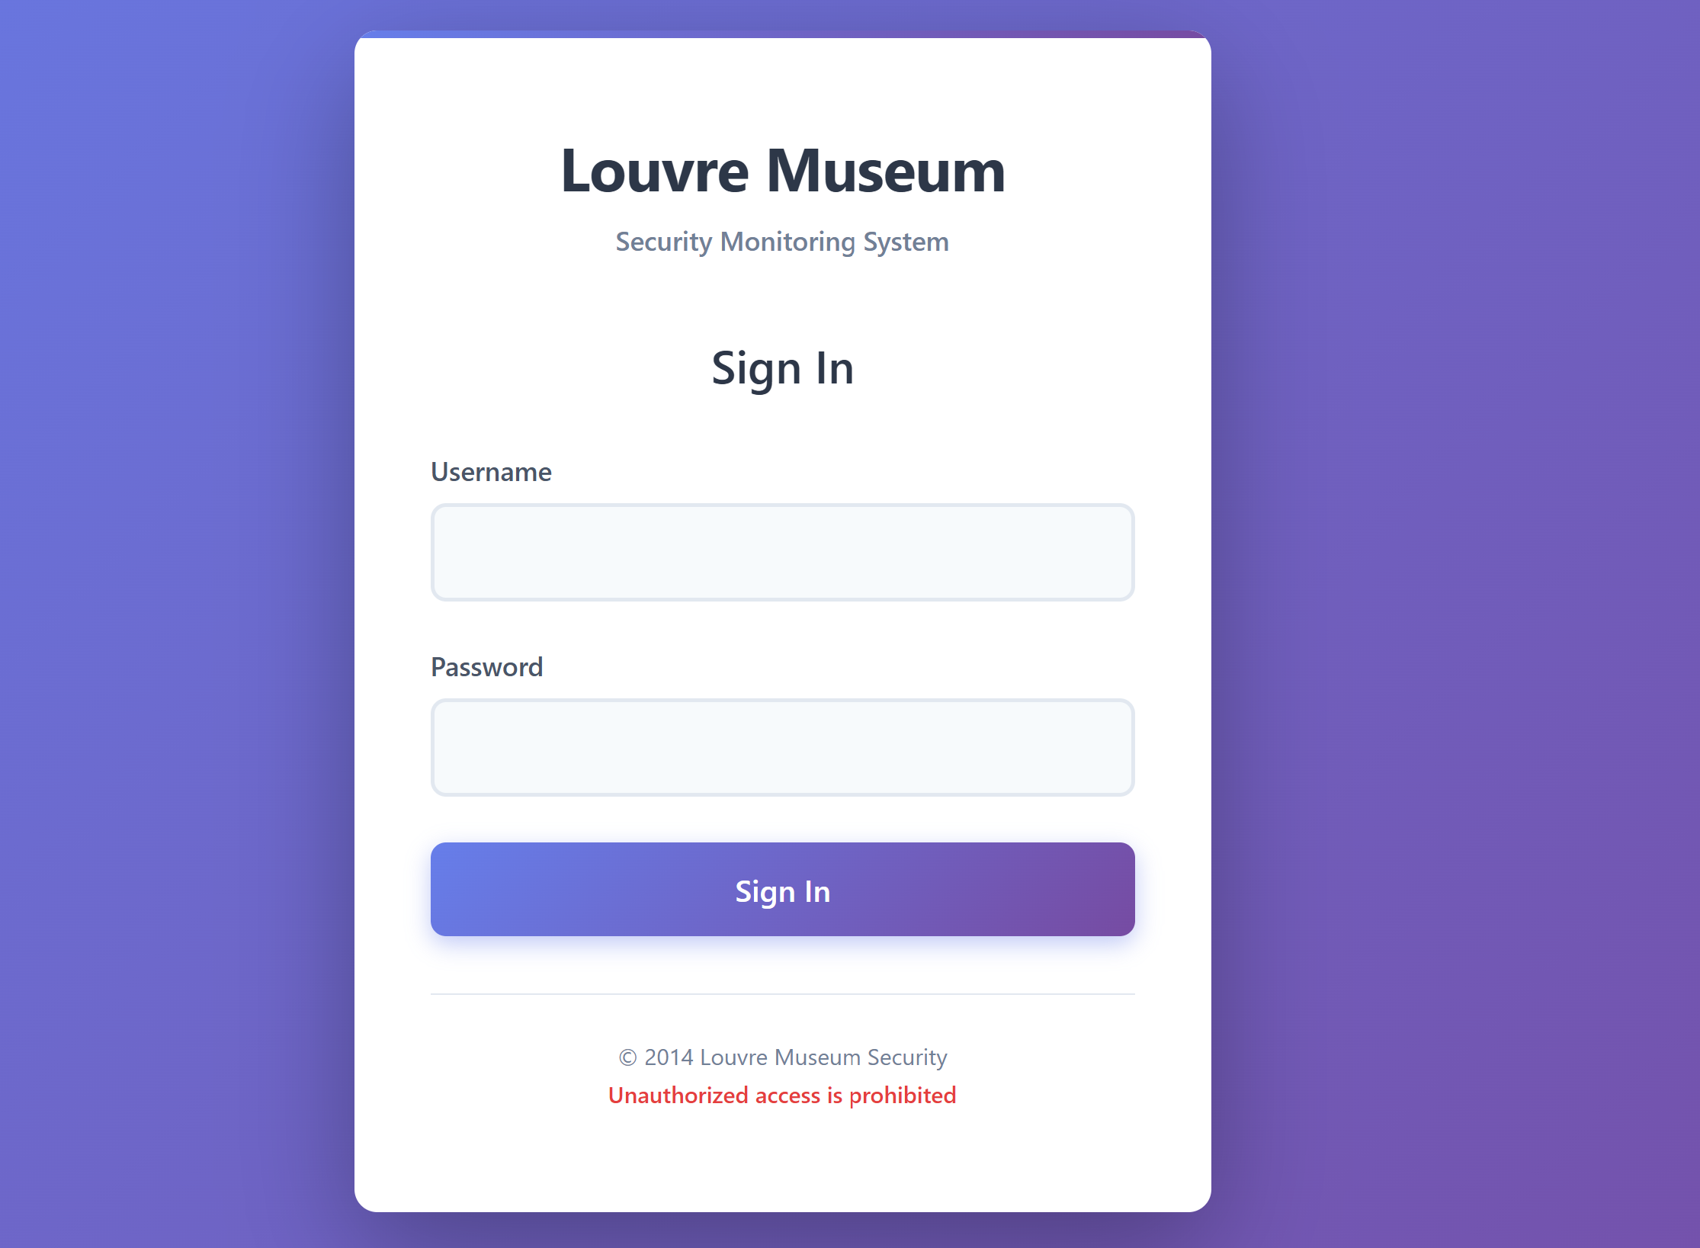
I saw here a login page, so I immediately entered test credentials “test”, “test” and tested it. I saw this error message:
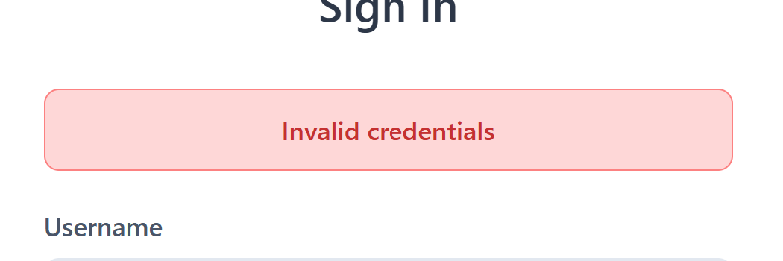
Then, I started using some common weak credentials to check if one of them works but unfortunately it didn’t work.
At this point, I read again the description and understood that I need to find the credentials from online sources.
The password I found after short investigation about the heist incident what “LOUVRE.”. This weak password was the actual password of the CCTV cameras of the louver.
The username I found just entering possible usernames that connect to the password (after I didn’t found any other username).
After successfully logging in, I was moved to this page:
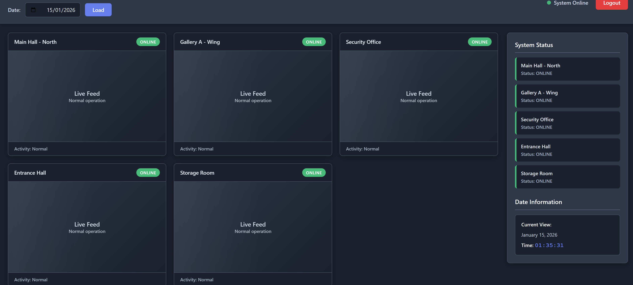
From here, I tried to see the heist date and found the flag:
